Justin Brown

CS-340

Project Two Readme

1). Original Chart before modifications

2). Water rescue button

3). Mountain button

4). Disaster

5). Reset

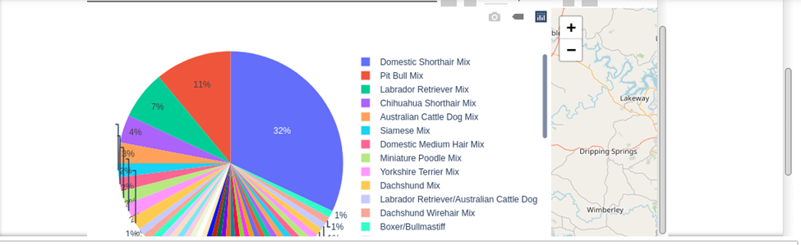

*Be sure to explain why MongoDB was used as the model component of the development, including what specific qualities or capabilities it provides for interfacing with Python.*

MongoDB was used as the model component of the development because it works nicely with python. This allows for the different buttons and data sorting and visualization tools to be used.

*Be sure to explain the Dash framework that provides the view and controller structure for the web application.*

Dash framework is used because it allows us to build this data app using its built in functionality. Dash is used through the web browser, so it allows for our visual representations to be updated in real time.

*Be sure to include links to any resources or software applications that were accessed or used*

<https://dash.plotly.com/introduction>

<https://dash.plotly.com/dash-core-components/graph>

<https://dash.plotly.com/datatable>

*Explain the steps that were taken to complete the project*.

First, a CRUD python module was created in project one. This was then imported to help with this project. This project was focused on building interactive options that allow the user to sort the data. Also, widgets were created to allow to see this updated data occur in real time. First, the logo and my identifier were added to the top. Next, the data table was populated using the python module that I created. Next, filter options were added to the data table. Lastly, I attempted to create the pie chart. The chart semi works as intended.

*Identify any challenges that were encountered and explain how those challenges were overcome.*

I encountered many challenges while completing this assignment. One challenge I encountered was getting the pie chart to render. After going through the online documentation, I was able to get it to work. Another was getting the image at the top to be the correct size. I looked through some html documentation and was able to figure it out.